Ideation Phase
Brainstorm & Idea Prioritization Template

Date | 29 September 2026
Team ID | 6ab3da83a238dc999eb399a3
Project Name | AI-Augmented BlogNest API
Maximum Marks | 4 Marks

Brainstorm & Idea Prioritization
Brainstorming provides a creative and collaborative environment for generating innovative ideas for the AI BlogNest API. It encourages team members to explore different possibilities for developing an AI-powered backend that can efficiently manage blog content, users, and API operations.
During the brainstorming process, ideas such as AI-assisted blog generation, content summarization, keyword generation, category classification, user authentication, blog management, search functionality, and RESTful API integration can be discussed and developed. The focus is initially placed on generating a wide range of ideas without limiting creativity. These ideas are then evaluated and prioritized based on their usefulness, feasibility, technical requirements, and contribution to the overall system. This process helps in selecting suitable features and shaping an effective and intelligent backend solution for the AI BlogNest API.
Step-1: Team Gathering, Collaboration and Select the Problem Statement
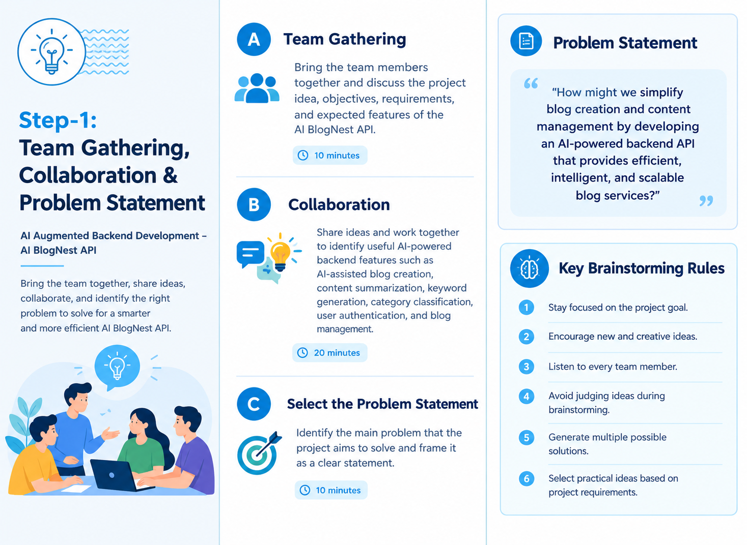
Step-2: Brainstorm, Idea Listing and Grouping
